Challenges
- Launch one aws ec2 and install jenkins.
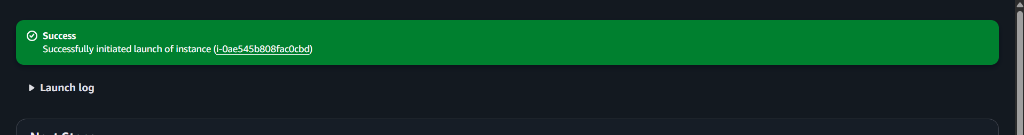

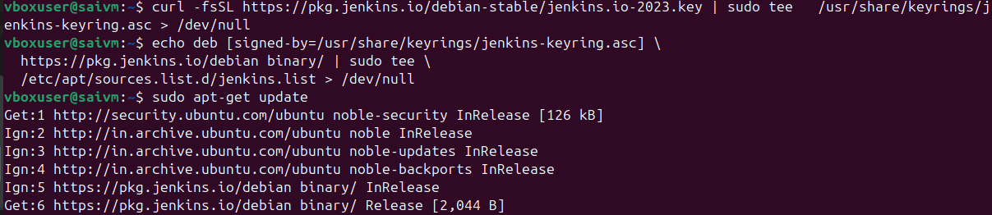
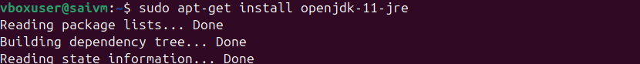
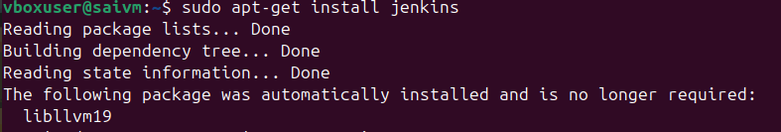
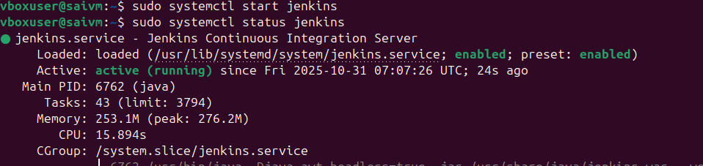
In amazon linux or gitbash
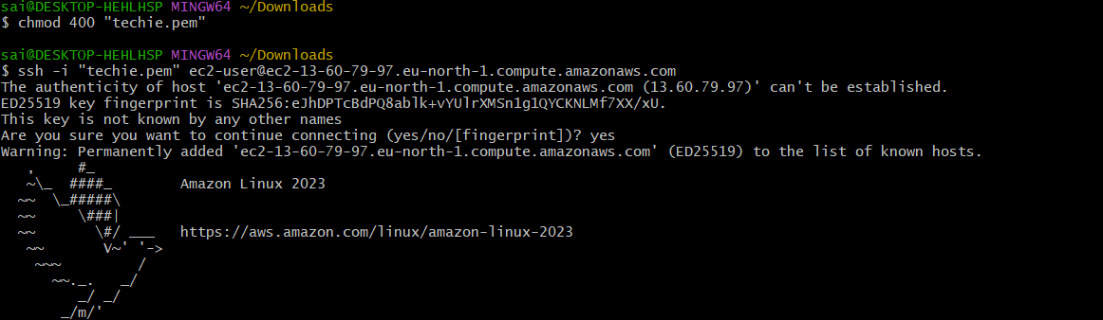
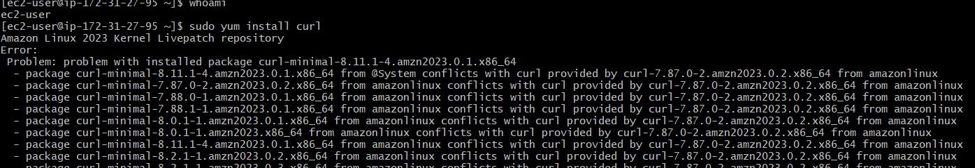
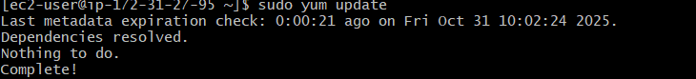
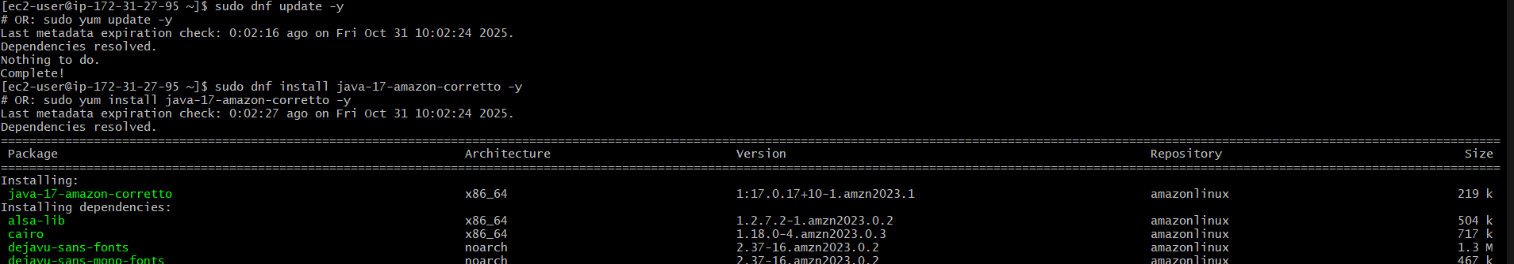
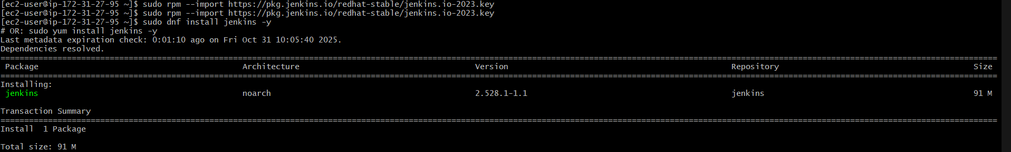
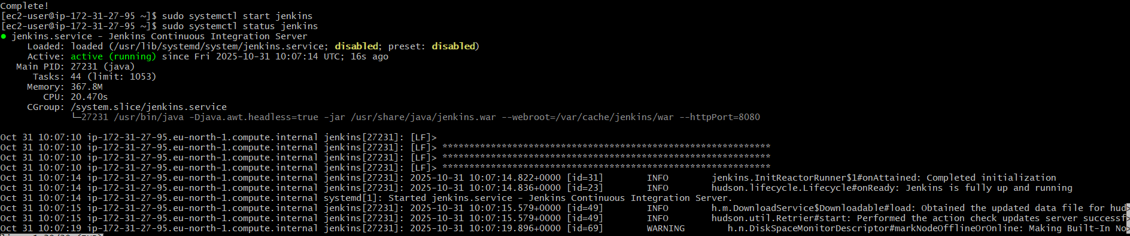
- Setup Apache Tomcat on Ubuntu Virtual Machine

Download file form website
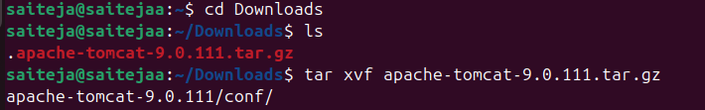
Then
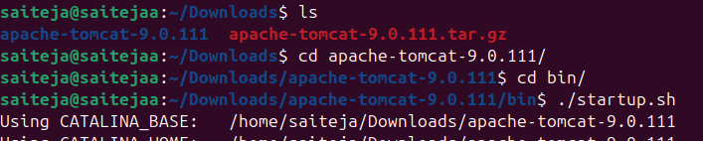

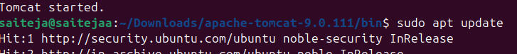

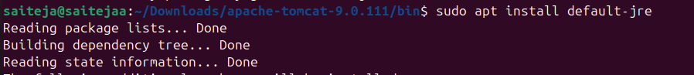
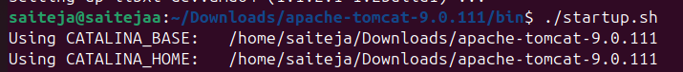
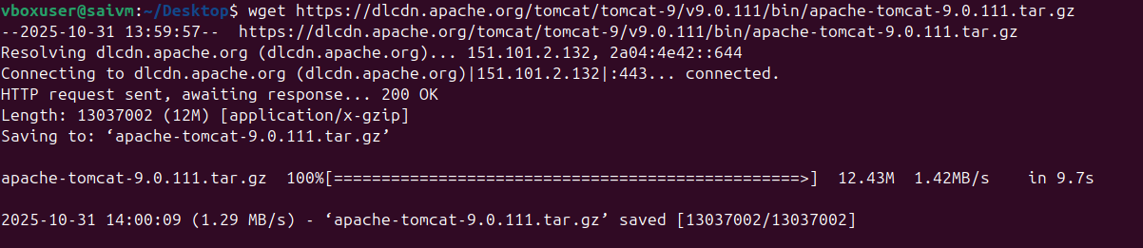

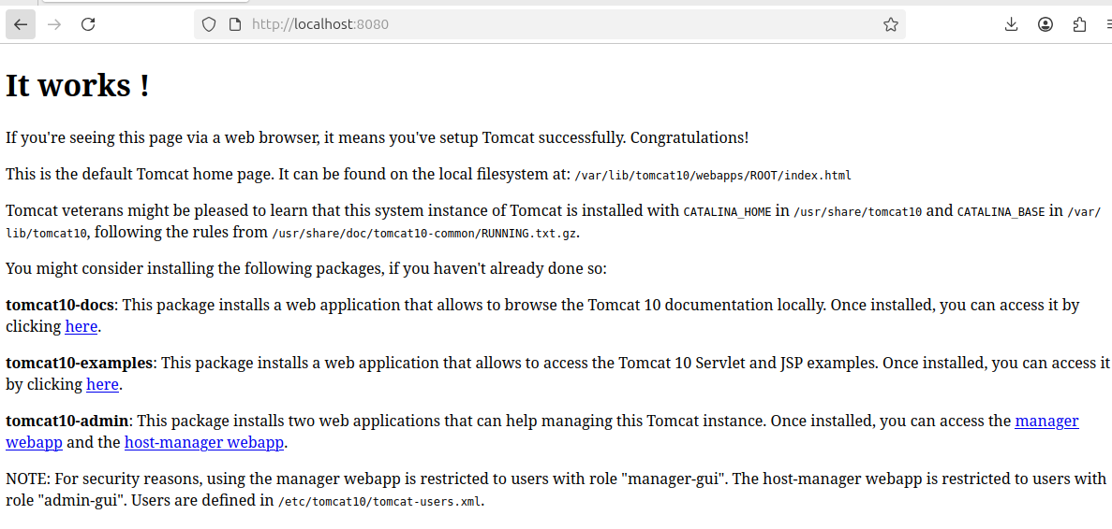

- Setup Docker Desktop on your local windows.

